
Auckland University of Technology

ENSE707 – Software Quality
Assurance
GitHub Link: https://github.com/laksrahaha/Hospital-Management-System---Software-Quality-Assurance-
Assessment 1
Mid Project Scoping Report

Group:
Hita Viswanathan - 23199037
Sravani Kunapuli - 23198431

Table of Contents
Introduction 4
Task 1: Problem Definition & Approval 4
1.1 Background and Problem Statement 4
1.2 Stakeholders and consultation 4
1.3 Quality issues, relevance, ad feasibility 5
Task 2: Requirements & Quality Analysis 5
2.1 Functional requirements 5
2.2 Non-Functional requirements 7
2.3 Acceptance criteria and requirements validation 9
Task 3: Propose Solution and initial prototype-hita 9
3.1 Proposed system and architecture 9
3.2 Patient dashboard functionality 10
3.3 Referral functionality and integration 10
3.4 Prototype scope and limitations 11
Task 4: AI-Assisted development using GitHub copilot 11
4.1 Copilot usage for development 11
4.1.1: Adding a Patient 11
4.1.2: Editing Patient Details 13
4.1.3 Usability and Validation Review 15
4.1.4 Referral Validation and Integration review 16
4.2 Human review modification and testing 18
4.3 Copilots’ limitations 19
Task 5: Initial test Strategy and Test planning 19
5.1 Test scope and objectives 19
5.2 Test Levels and Test types 20
5.3 Test Environment 20
5.4 Entry/Exit Criteria 20
5.5 Defect Management 20
Task 6: Initial test cases and requirements traceability 21
6.1 Test case design and execution 21
6.2 Test results and evidence 21
6.3 Requirements traceability matrix 24
Task 7: Progress, Risks and Next Steps 24
7.1 Current progress and limitations 24
7.2 Risk and mitigation 24
7.3 Part 2 and future improvements 25
Conclusion 25

Introduction
Software Quality Assurance is important for making sure a system works correctly, safely, and reliably. This is especially important in hospitals because the system handles private patient information and supports the work of patients, doctors, nurses, and administrators.
In this report, we analyse and improve an existing Hospital Management System using Auckland Hospital as the real-world context. Our prototype focuses on patient information and referrals, including validation, priority, and status handling. We explain the quality issues identified, the testing completed and the improvements needed to make the system more reliable and easier to use.

Task 1: Problem Definition & Approval

1.1 Background and Problem Statement
For this project, we selected an existing Hospital Management System to analyse from a Software Quality Assurance perspective. Hospital information can become difficult to manage when patients and staff use separate or unclear processes. This may lead to missing information, delayed referrals, access problems, and errors.
Our aim is to create one reliable system where important information and workflows are easier to access. Authorised users can access patient and referral information while private information remains restricted. The project focuses on improving the quality and reliability of the existing system rather than developing a complete hospital system.

1.2 Stakeholders and consultation
The main stakeholders identified were patients, doctors, nurses, and administrators because they use hospital information in different ways. Patients need access to their own information, while doctors and nurses need accurate details when making clinical decisions and managing referrals. Administrators are responsible for managing records, users, and access.
We also consulted a healthcare professional, so the project was not based only on our assumptions. We learnt that clinicians may review medical history, allergies, medications, previous appointments, and recent activity before making referral decisions. Referral priority and status were also identified as important because urgent cases need to be recognised and incomplete referrals may be returned. This helped us narrow the project to a focused patient and referral workflow.

1.3 Quality issues, relevance, ad feasibility
The main quality issues identified were missing or incorrect patient information, incomplete referrals, referral delays, unclear navigation, and unauthorised access. These issues are important because mistakes could affect clinical decisions or prevent staff from accessing the correct information. Therefore, the prototype focuses on reliability, usability, validation, security, and maintainability.
The project is achievable because the scope has been limited to the main patient and referral workflow. It uses ASP.NET Core, Entity Framework Core, HTML, CSS, and JavaScript, with GitHub used for version control. Full authentication, real Auckland Hospital data and wider workflows such as discharge and laboratory management remain outside the current prototype.

Task 2: Requirements & Quality Analysis

2.1 Functional requirements
The functional requirements that were selected for the prototype were based on the healthcare referral workflow. This workflow was investigated during the project as opposed to being selected from the general software requirements. A stakeholder interview was conducted, and it was found that staff in the hospital required access to information such as a patient’s medical history, current medications, allergies, previous appointments, and recent hospital activity when dealing with active referrals. It was found that before a patient has even visited a Clinician their case is reviewed by default just in case of further referrals or action. Using this interview the information
that was represented in the patient and referral components of the system were
developed. Features such as retrieving patient records, displaying relevant patient information, and associating referral information with the correct patient all became functional requirements that were necessary when developing the prototype for the first half of the project. Another feature that was considered was Referral priority and status because the stakeholder interview identified that different urgency levels and outcome dictated if the referral was going to be returned or rejected. In terms of Quality Assurance, defining these behaviours gave us the specific functions which we could then later test as opposed to relying on a general expectation that a referral system should be functional.

ID | Functional Requirement | Stakeholder / Project Reason | Prototype Evidence
FR01 | The system shall display available patient records. | The stakeholder identified the need for clinicians to quickly access patient information before making referral decisions. | The patient page retrieves and displays active patient records from the backend/database.
FR02 | The system shall allow a clinician to open an individual patient record. | Clinicians need patient-specific information rather than only a general patient list. | A selected patient can be opened and retrieved using the patient ID. Invalid IDs are handled without returning an unrelated record.
FR03 | The patient view shall display relevant clinical information including identifying information, patient status, allergies, and medical history. | The stakeholder identified medical history, allergies, and other patient information as important when assessing the patient. | The patient detail/dashboard view displays the relevant patient information stored in the patient model.
FR04 | The dashboard shall provide a clear overview of patient and referral activity. | Lecturer feedback and stakeholder discussion narrowed the project from a general hospital system to a focused clinical workflow. | The prototype contains dedicated Dashboard, Patients and Referrals views with shared navigation and summary information.
FR05 | The system shall allow a referral to be created for a patient. | Referral creation is the main workflow being addressed by the project. | The referral interface sends referral information to the referral API, which creates a referral linked to a patient.
FR06 | A referral shall require a referral reason before it can be submitted. | The stakeholder explained that incomplete referrals can be returned and that the reason for referral is necessary for assessment. | Referral validation rejects submissions where the reason is missing.
FR07 | A referral shall require a priority classification before submission. | The stakeholder identified referral priority and triage as important because referrals are handled according to urgency. | The referral workflow requires a priority and supports the defined priority values such as P1, P2 and P3.
FR08 | The system shall record and display the current referral status. | Staff need to know what has happened to a referral after submission. | Referral status can be retrieved and updated using defined status values such as Pending, Accepted, Returned, Rejected and Completed.
Table 1: Table of Functional Requirements

2.2 Non-Functional requirements

Alongside the functional features of the prototype Quality requirements were also considered. This is because the system needed to behave as a complete application and not simply demonstrate individual functions. A quality requirement that was addressed was Reliability. An example of the application of reliability in the system is that when a patient record is updated and the information associated with the is returned, the updated information remains correct even after being stored. Upon the retrieval of the information the second time, the correct information is still displayed. If a mismatch had occurred between the patient and their referral or medical information, it would be treated as a reliability defect.
The second quality requirement that was applied is Usability. By using clear navigation, patient search and grouped patient information usability was demonstrated and supported consistently throughout the system. It allows for the users to quickly reach the relevant information without having to undergo unnecessary steps. For example, a user can easily find the referral of the patient using the priority of their referral. Maintainability was also another component that was considered. Maintainability was used to separate the system into database models, controller/API logic, and frontend components. This made changes easier to manage and made defects easier to locate in the item of testing. Security was also considered because the prototype handles sensitive healthcare information. Together all these quality requirements provide measurable behaviours that can be evaluated through testing.

ID | Quality Attribute | Non-Functional Requirement | How It Relates to the Prototype
NFR01 | Usability | Important patient information should be accessible from a clear patient view without requiring unnecessary navigation. | The patient detail/dashboard brings identifying information, status, allergies, and medical history into the clinical view. TC04 provides initial usability evidence.
NFR02 | Reliability / Data Integrity | Invalid or incomplete referral submissions shall not be accepted as valid referrals. | The API validates required referral fields such as reason and priority and rejects invalid requests. TC06 and TC07 provide evidence.
NFR03 | Maintainability | Patient and referral functionality should remain separated into appropriate models, controllers, frontend files, and data-access components. | The code separates patient and referral models/controllers and separates Dashboard, Patients and Referrals interface functionality.
NFR04 | Security | Access to identifiable patient information should be restricted to authorised healthcare staff. | The requirement is identified because the prototype handles sensitive clinical information. Full authentication and role-based access control are not yet implemented and remain future work.
Table 2: Non-Functional Requirements

2.3 Acceptance criteria and requirements validation
The acceptance criteria were defined using the main workflow of the referrals in this prototype. Patient list was expected to display available patient records, When the patient was selected accurate clinical information had to be displayed. Referral
information also had to remain linked to the correct corresponding patient. When
a referral was being created, the required referral details needed to be entered and
saved successfully. The selected priority and status details needed to be displayed
correctly afterwards. As a team we made use of these criteria so that clear conditions could be checked during testing rather than us relying on the general judgement that the system was adequate and working.
The requirements were validated against the stakeholder research that was completed earlier in the project. Using this research, we were able to identify the information healthcare staff needed when reviewing referrals, including medical history, medications, allergies, previous appointments, test results, recent hospital visits all of which could be used to determine the referral priority. Using this information, we were able to confirm that the Mid project prototype requirements were accurately represented in the referral workflow instead of us assuming during the development phase as we did previously. After discussing with the physicians in real time, we were able to discard the earlier ideas and requirements we had for the prototype and were able to link the requirements to test cases through the traceability matrix so that the team could check whether each important requirement had been verified.
The requirements were review for clarity , completeness, consistency, correctness, feasibility and testability. The earlier identifies requirements were less specific and too broad for the required scope. The stakeholder and lecturer feedback helped o narrow these down. The final requirements now user clearer measurable behaviours such as requiring referral reason/priority and defined status values. The requirements were also checked to make sure that they were achievable in this current prototype. The RTM was rh used to confirm that the requirements ere testable

Task 3: Propose Solution and initial prototype-hita

3.1 Proposed system and architecture
Our first idea was a broad hospital system containing login, signup, role-based dashboards, and several hospital workflows. Lecturer feedback showed that the project needed to address a clearer real-world problem and include stakeholder consultation. We therefore narrowed the scope to patient information and referrals.
The prototype separates the frontend, API/controller logic, models, and database access. This structure makes the system easier to maintain, test and update without changing every component.

3.2 Patient dashboard functionality
The patient dashboard was developed so it could be the main point of access for managing the patient records before the user moved onto the referral workflow. It works byt the patient page reteieving the active apteint record from the backedn. The user is allowed to search for an indivisal for their spefci medical information. The patient record can also be edited and a new atent can also be added, the chages are supported throuuhg the API & Database storage system instead of just having sample data for the fronted.
As the project progressed, we gained better undestaing of the way the records should behadled and we mahed to futher develop the patient functionality. One such addition was the archive a resotre feature which allows for the user to temporarily move an inactive patient or a ptient they are no longer dealing with into an archived view and they can later be restored and added back to the activr aptients list, if need be, as opposed to permnanty removing patient records. The idea for this function came from the interview with the stakeholder where they mentioned that often they hav man patint who’s records are stuck at the previous medical centre and because they don’t have access to a shared countrywide database they have to add and remove patient manually. This function therefore allowed for inactive records to still be alvailbe but also be separated from the patient scurrently involved in the workflow.
As my team member and I continued to work on out interface while we were integrateing our work further refinements were made. A seaprte dashboard was first created apteint and referalmpages were dvlped using a hshared navigation system. The patient page as mentioned above contained features sucha s active and archived views, search, patient details a dfunctionaliy for editing. Thes changes allowed for out prortype to reperesnt the intend worlflow more clsoesly. It helped for us to represet ehwroflpw that staff use to reieew patient information better before we moved onto the referral related actions.

3.3 Referral functionality and integration
The prototype for the referrals focus was to develop a referral workflow so staff could create and manage referrals within Reserve Health. The form allows the user to select an existing patient, enter the referral reason and service, and choose a priority. The latest merged code restricts priority to P1, P2 or P3 in both the frontend options and backend controller. This prevents unsupported priority values from being accepted. Required field validation also rejects a referral when the reason or priority is missing and gives the user a clear error instead of creating an incomplete record. For a new referral with status pending, it is details can be retrieved and displayed in the referrel list. Where staff can view patient, reason, priority, and status. We decided to add the Edit Referral option so the priority and status can be changed as the referrel moces thorugh the workflow. The defined status is Pending, Accepted, Returned, Rejected and Completed. The frontend uses JavaScript to send requests to the referrel API, while the controller validated and processes the information. During integration we kept tjeelements IDs because referrals.js was dependent on them and adjusted the work to match the updated layout and separated CSS files completed.
New referrals are automatically assigned a Pending status when they are created, as the referral has not yet been reviewed at this stage. The status can then be changed through the Edit Referral function to Accepted, returned for more information, Rejected or Completed. This was done so that the referral status follows the actual referral process instead of allowing a status to be selected before the referral has been reviewed.

3.4 Prototype scope and limitations
The prototype focuses on the main patient and referral workflow rather than every function of a complete hospital system. The features implemented in this protype are the basic login/signup page .It uses test information and is not connected to Auckland Hospital. Authentication, role-based access, and the patient to referral database relationship still require further work. Wider functions such as discharge, laboratory results and medication management are outside the current scope.

Task 4: AI-Assisted development using GitHub copilot

4.1 Copilot usage for development

4.1.1: Adding a Patient
Purpose
At this stage of the interface, the patient sections main capabilities were being able to retrieve and display existing patient records and display the selected records. I wanted to expand the functionality of the patient management system so that new patient records coud be added apart for the existing seeding data that we had used for sampling and testing purposes. This was an important function to include because in the stakeholder interview with the clinicians, it was identified that things such as medical history, allergies and other patients' details were very nessesary when managing patient. SO,they should have to be able to add these details and new patients if needed. Copilot was used to help set up the backend POST endpoint and save time creating the method structure from scratch.
Prompt used : can you help me add a post method here so I can add a new patient to the database

Copilot suggestion :
// ...existing code...

[HttpPost]
public async Task<ActionResult<Patient>> CreatePatient(Patient patient)
{
_context.Patients.Add(patient);
await _context.SaveChangesAsync();

return CreatedAtAction(
nameof(GetPatient),
new {id = patient.PatientId },
patient);
}

// ...existing code...

Evidence:
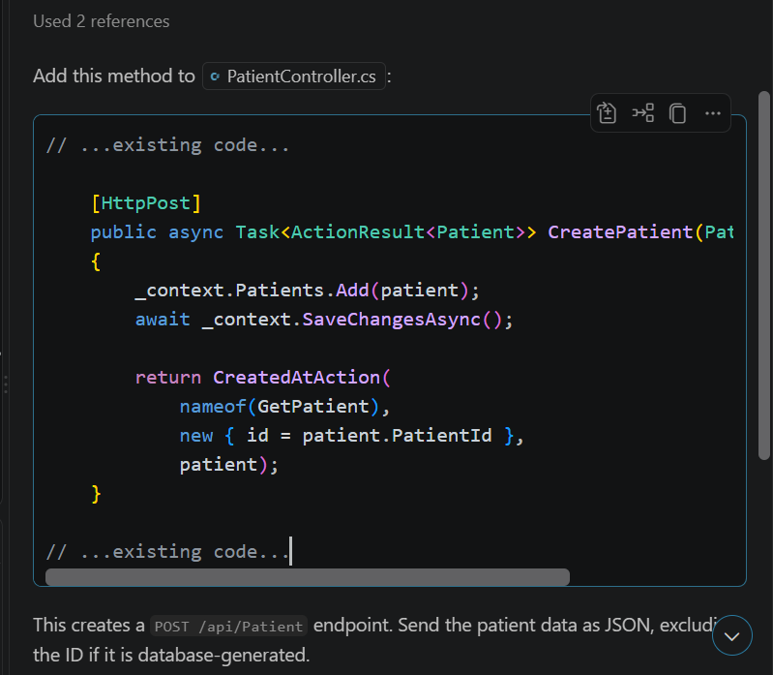

4.1.2: Editing Patient Details
Purpose:
After adding the ability to create new patient records, the next step was to allow existing patient information to be updated. The patient section could already retrieve and display individual patient records, but there was no way to correct or change information once a record had been created. This was important because patient information such as status, medical history, allergies, and location may need to be updated over time. GitHub Copilot was used to help create the backend update method and connect the edit functionality to the frontend.
Prompts Used:
- can you add a method so I can update an existing patient using the patient id
- can you help me connect the edit patient feature to the frontend so i can change a patient detail from the patient page
- is there anything simple I should improve in this edit patient feature for validation or error handling

Copilot Suggestion:
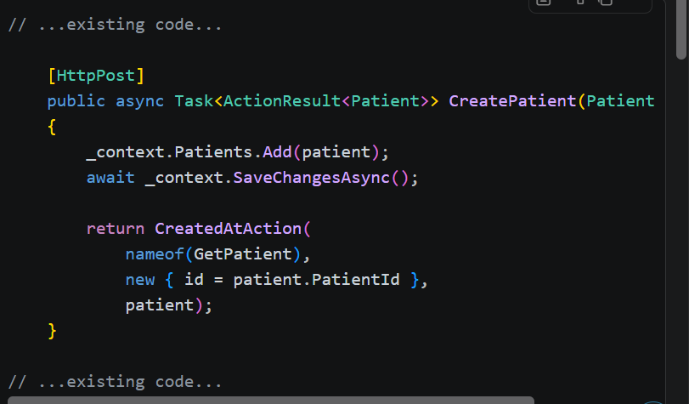
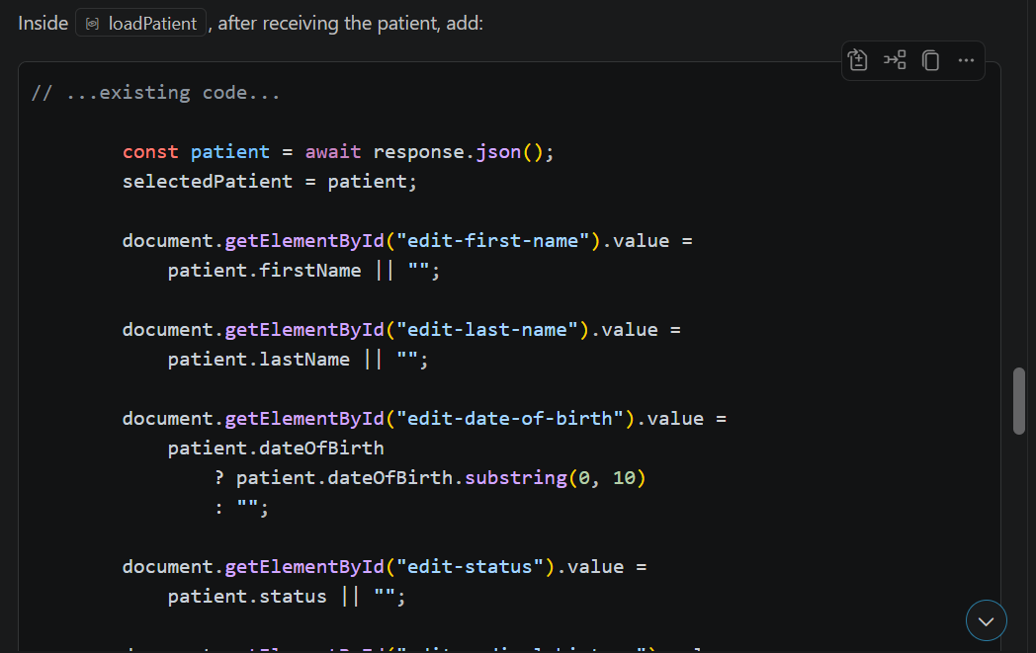
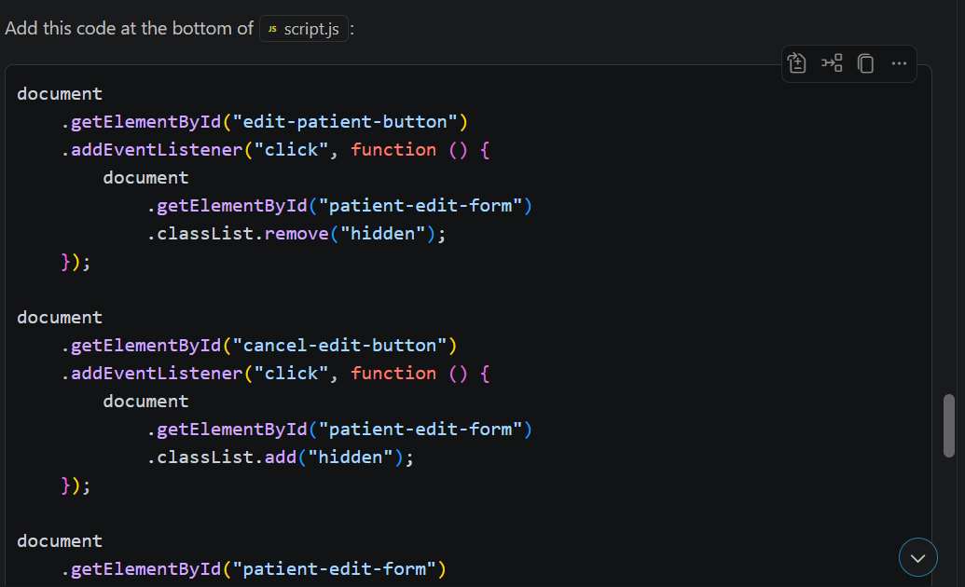
Copilt suggested changes too, selectdPatient variable to keep trac fo the pateints being edited, it also suggested lpgic to create a frm using the current patient details, and the javascrip which at the time was called script.js to submit the updated information to the API.

4.1.3 Usability and Validation Review
Purpose:
Once the patient edit functionality was working, Copilot was used again as a review tool rather than only for code generation. The aim was to identify simple usability and validation improvements that could be applied without redesigning the whole patient interface. This was useful because the patient page contains clinical information and editable fields, so clearer controls and basic input restrictions could reduce accidental or invalid input while keeping the prototype easy to use.

Prompt Used:
can you review this edit patient section and tell me if there are any simple usability or validation improvements I should make

Copilot Suggestion:
Copilot suggested that we improve the form labels and accessibility, b using more appropriate input types so more specific types, adding validation to the required fields if not already there, and applying character limits to larger text inputs

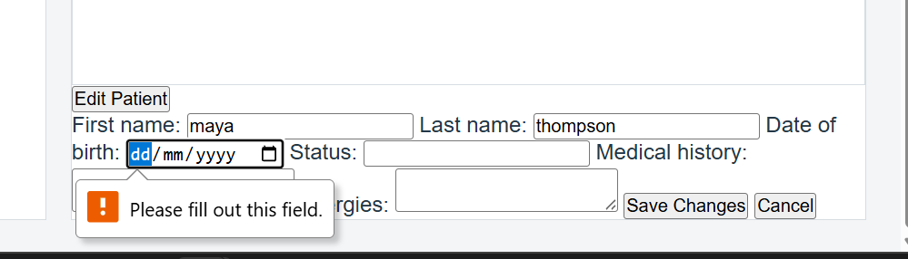
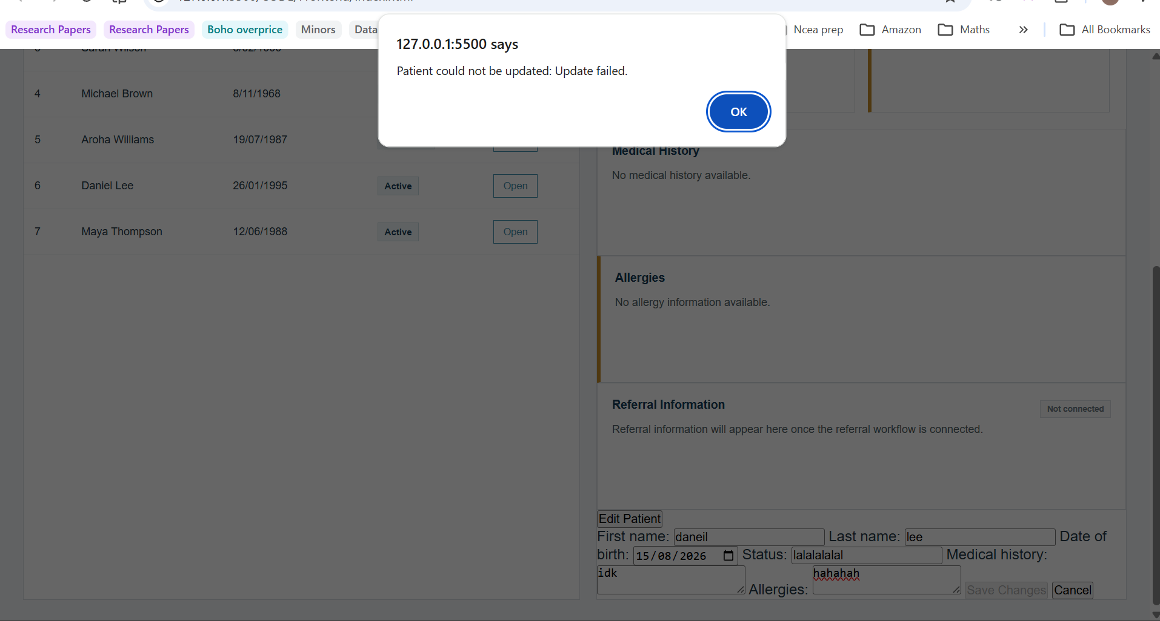

4.1.4 Referral Validation and Integration review
Purpose: Copilot was used to review the referral controller, model and frontend code. The purpose was to check whether the required-field validation, P1/P2/P3 priority handling, referral statuses and connection between the frontend and API matched the project requirements.
Prompt used: Review the selected referral controller code. Check that Reason and Priority are required, Priority only accepts P1, P2 or P3, and Status only accepts Pending, Accepted, Returned, Rejected or Completed. Do not rewrite unrelated code. Explain what is working correctly and identify any validation or error-handling issue that still needs attention.
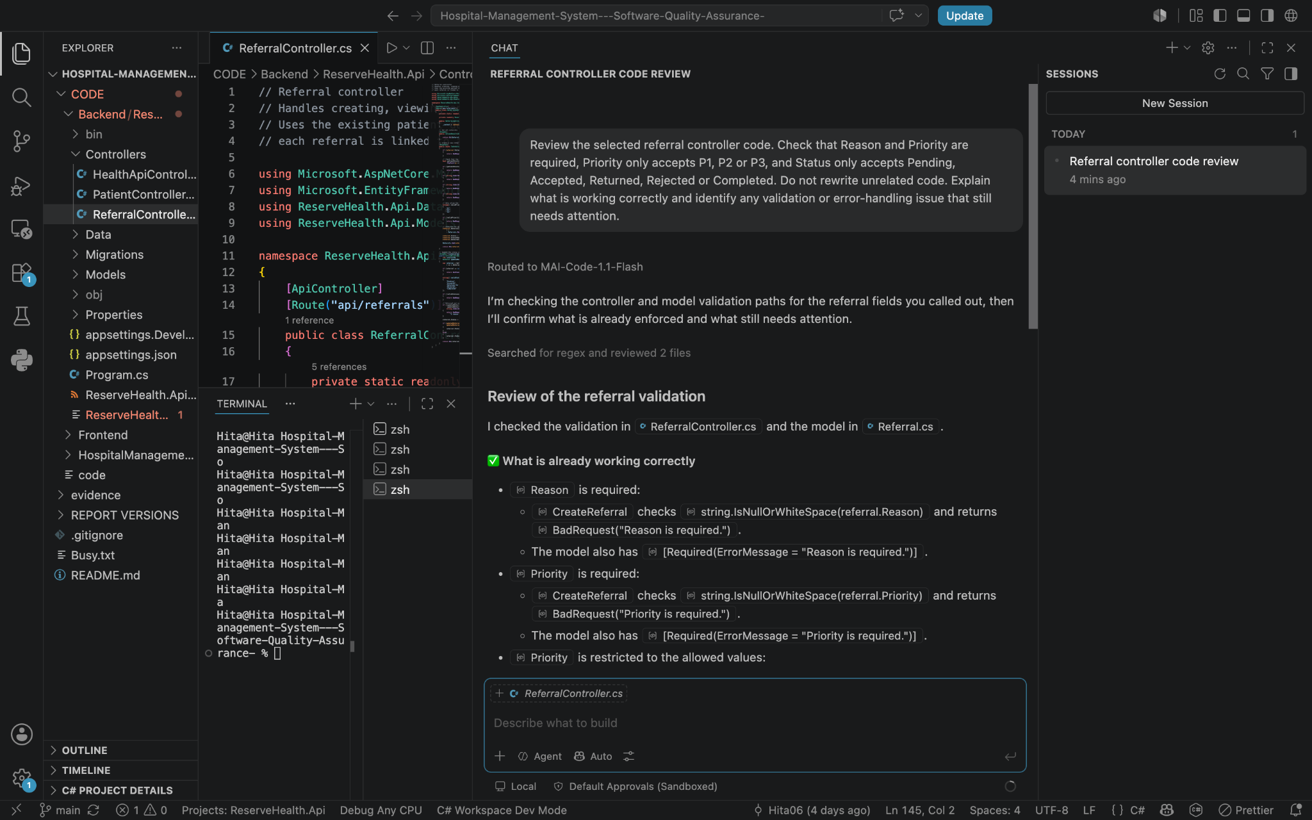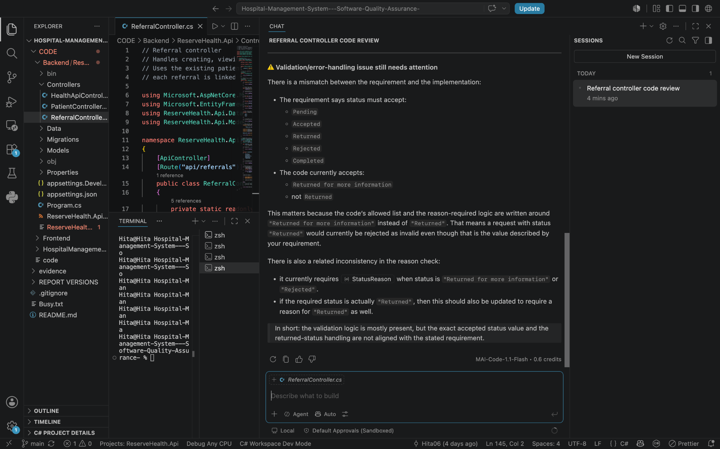
Prompt 2: Review the selected referrals.js code and its connection with referrals.html. Check that referral creation and editing send the correct information to the API, the existing HTML element IDs are not renamed, validation errors are clearly shown to the user and Edit Referral can update Priority and Status. Do not change the code yet. Give me the review findings first.
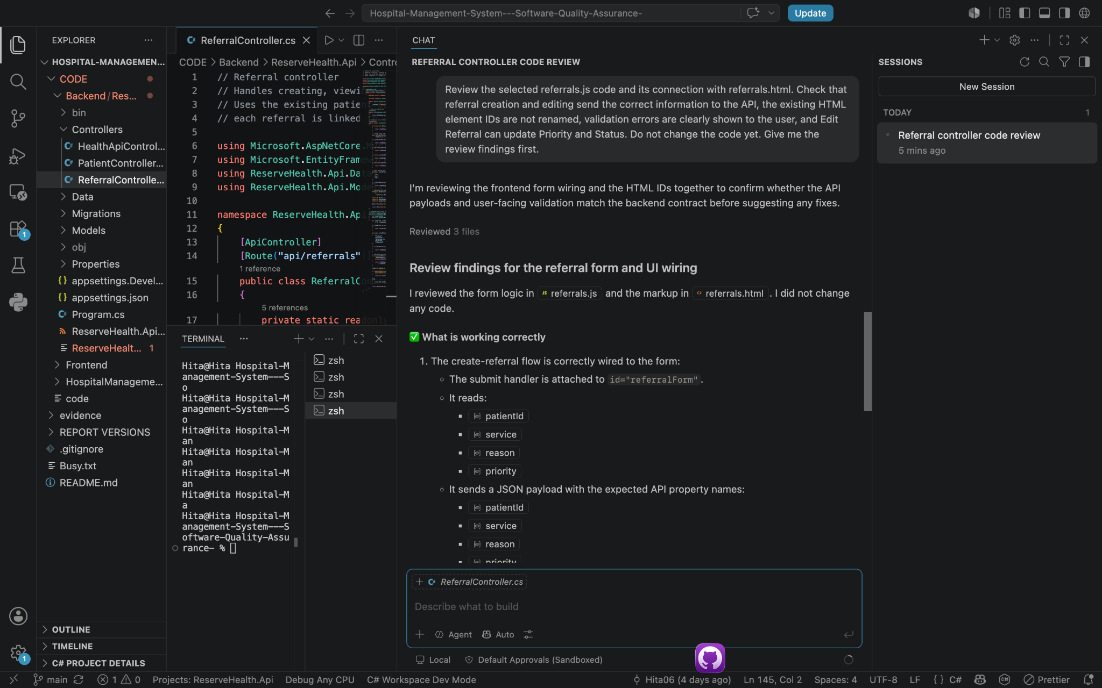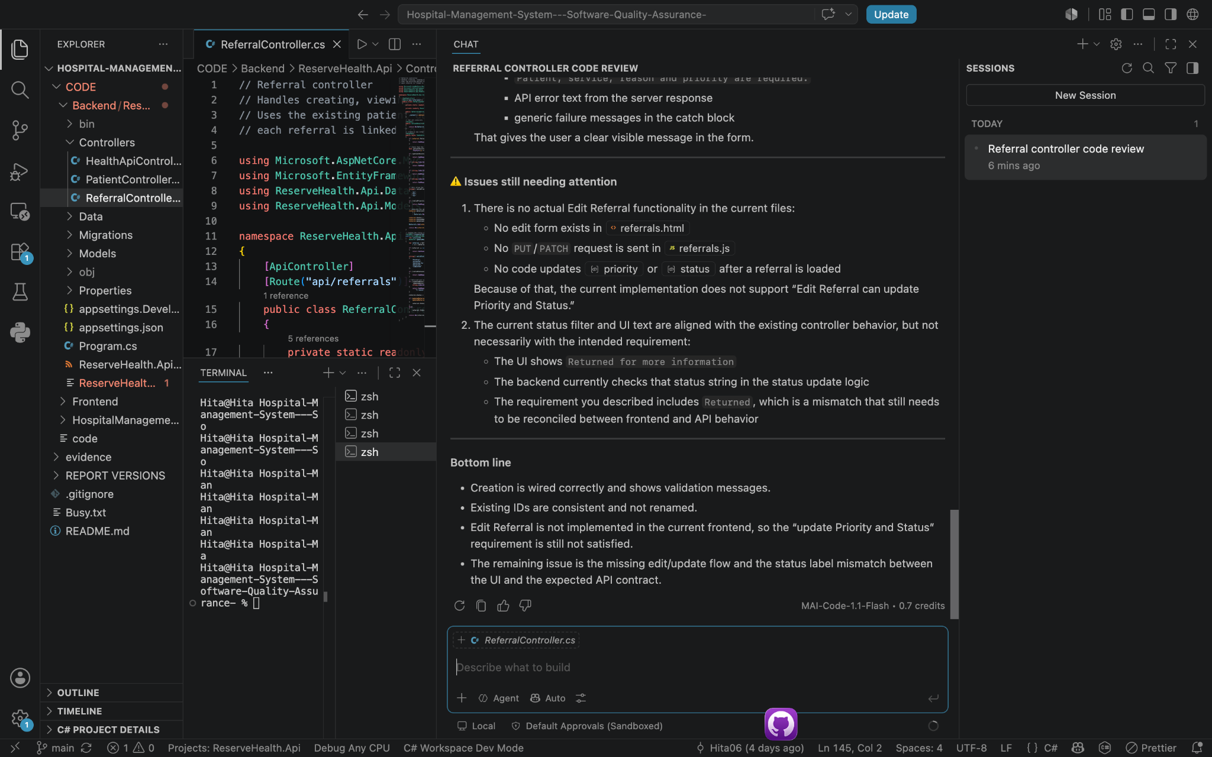

4.2 Human review modification and testing
Copilot’s findings were manually compared with the referral requirements and current merged code. The required Reason and Priority validation and P1/P2/P3 handling were confirmed as correct. The existing HTML element IDs were also kept because referrals.js depended on them.
The review identified two remaining integration issues. The controller used “Returned for more information” while parts of the report used “Returned”, and the original review identified edit referral as missing. The issue was the confirmed and resolved , it was altered and merged and the testing proved that it was working. These findings were recorded instead of automatically accepting or hiding them.
The referral behaviour was also tested through the frontend and direct API requests. A valid referral was accepted, submissions with no reason or priority were rejected, and the initial Pending status was retrieved and displayed. This showed that Copilot’s findings still required human review and testing before they could be trusted.

4.3 Copilots’ limitations
Copilot could generate code that looked correct without understanding every referral rule or the existing project structure. It could omit validation, accept unsupported values, or change frontend elements that other files depended on. It also could not confirm that the patient, referral, API, and database parts worked together. For this reason, its suggestions still needed manual review, modification, and testing.
Copilot seemed a little underwhelming for the actual QA side of the project, since most of the suggestions were quite bare bones and it did not really help much with thinking of proper QA practices by itself. Human checking was still needed for the prompts and suggestions because they did not always work exactly how I needed them to, and some parts were also quite redundant, so I removed or changed them. It was useful for more repetitive and simple tasks, and it did save some time there, but for better logic and deciding what made sense for the system, human review was still needed to cross check and edit the suggestions before using them.

Task 5: Initial test Strategy and Test planning

5.1 Test scope and objectives
The initial test strategy's purpose was to collect evidence that the main patient and referral workflows performed as expected across the whole prototype. Functional requiremtnes, acceptance criteria, identified risks and the implemented system design were used to form the test basis. During the testing we focused on core worlfow rather than every possible eautre, higher prrioty was given to th features that would cause more damage if not runnin successfully. These high prrioty features consist of patient retrieval and display, patient management, referral creation, referral validation, priority and status handling, data persistence and interaction between the frontend, API, and database. Other features such as a full authentication, role-based access control, real hospital integration, discharge workflows, penetration testing and large-scale load testing were considered outside the scope of this phase since they were not a part of the functionality that we are trying to validate.

5.2 Test Levels and Test types
The we approached testing by separating tests levels from test types. Api and integration level testing were used to check the communication between the application components, while system testing was used to verify the complete behaviour of the system that was running through the prototype, for successful operations such as retrieving patient records and creating referrals, Functional testing was used. While for invalid behaviour, non-existent patient id, and missing referral reason or prtoty negative testing was used. Where information needed to be displayed, stored and correctly retrieved usability and data-integrity checks were used.

5.3 Test Environment
The same environment that was sued during development was carried out for testing as well. The backend was tested using the C sharp ASP>NET Core/.NET with Entity Framework core and SQL Server LOcalDB. The fronted was developed using HTML, CSS, JavaScript, and tested using the live server feature from vs code on google chrome. VS Code were used for development and debugging and direct API requests and the running application were used to verify if the backend logic was implanted successfully. As er the guidelines of the project GitHub were used for version control

5.4 Entry/Exit Criteria
The entry criteria, what has to be ready before a test is worth running of the project required that the project had to be built successfully without errors, the backend to database connection to be working, and the sample test data has to exists, the feature needs to be completed or needs to exist to be tested. Meaning that the feature must be accessible to the user through the UI or API to be able to test. The exit criteria, the criteria which dictates if the testing performed is adequate. The exit criteria for this project require for all eight planned test cases to be executed. The actual results and pass/fail outcomes be recorded, a major defect are fixed, and hen retested to make sure there are no further complication. The criteria also demand that any remaining limitation present need to also be documented. Any of the behaviours that have not been tested or accounted for in this testing phase pose as a residual risk during later development phases.

5.5 Defect Management
If tests fail during the testing phase any defects that were identified were recorded based on the difference between expected and actual behaviour. Each of the defects that were found could be documented using an issue description, expected result, the actual result and then fixing the defect and documenting the fixed outcome. This supported a consistent process of identifying a defect, applying a correction, and then retesting the affected functionality. Examples encountered during development included API failures, frontend and backend integration issues, and interface regressions after changes were merged.

Task 6: Initial test cases and requirements traceability

6.1 Test case design and execution
The initial test cases were developed using the functional requirements and acceptance criteria that was decided in task 2 of the project. * Tests were designed to cover the main patient and referral workflow. The patient side foth tests focused on retrieving and displaying patient information, while the referral side of the tests were more focused on the test creation, required feid validation and status handling. The tests were run by carrying out the API and browser interface depending on the behaviour that was being tested. This way the team was able to collect evidence at different parts of the porotype as opposed to soleoy relying on interface.

ID | Test Handler | Req. | Test | Expected Result | Type
TC01 | Partner 1 | FR01 | Retrieve patient list | Stored patient records are returned/displayed | Functional/API
TC02 | Partner 1 | FR02 | Retrieve valid patient by ID | Correct patient record is returned | Functional/API
TC03 | Partner 1 | FR02 | Retrieve non-existent patient ID | 404 Not Found is returned | Negative/API
TC04 | Partner 1 | FR03/FR04 | Open patient summary/dashboard | Required patient information is displayed correctly | System/Usability
TC05 | Partner 2 | FR05 | Submit valid referral | Referral is successfully created and stored | Functional/Integration
TC06 | Partner 2 | FR06 | Submit referral with no reason | Request is rejected | Negative/Validation
TC07 | Partner 2 | FR07 | Submit referral with no priority | Request is rejected | Negative/Validation
TC08 | Partner 2 | FR08 | Retrieve/display referral status | Correct referral status is stored and displayed | Functional/Data integrity
Table 3: Test Cases

6.2 Test results and evidence
Each test case was recorded as aapss or fail based o whter the behaviour of the system in the test matched the expected result that were clarified in the previous section. The cases were executed against the running prototype and alter compared against the expected results. Screenshots were the taken a s a form of evidence and documentation, the evidence includes before and after examples where the defect was identifies, the corrected and the tested. Therefore, a successful functionality and resolution process were demonstrated.

ID | Actual result | Status | Test | Before | After
TC01 | Patient records were return successfully and displayed accordingly | Pass | Retrieve patient list | 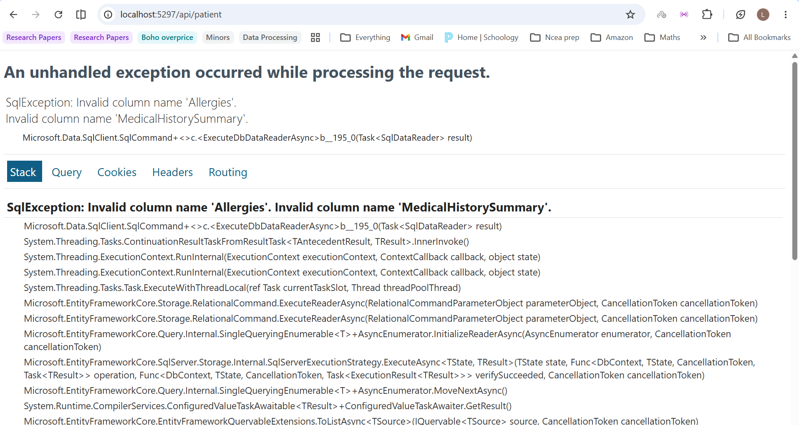 | 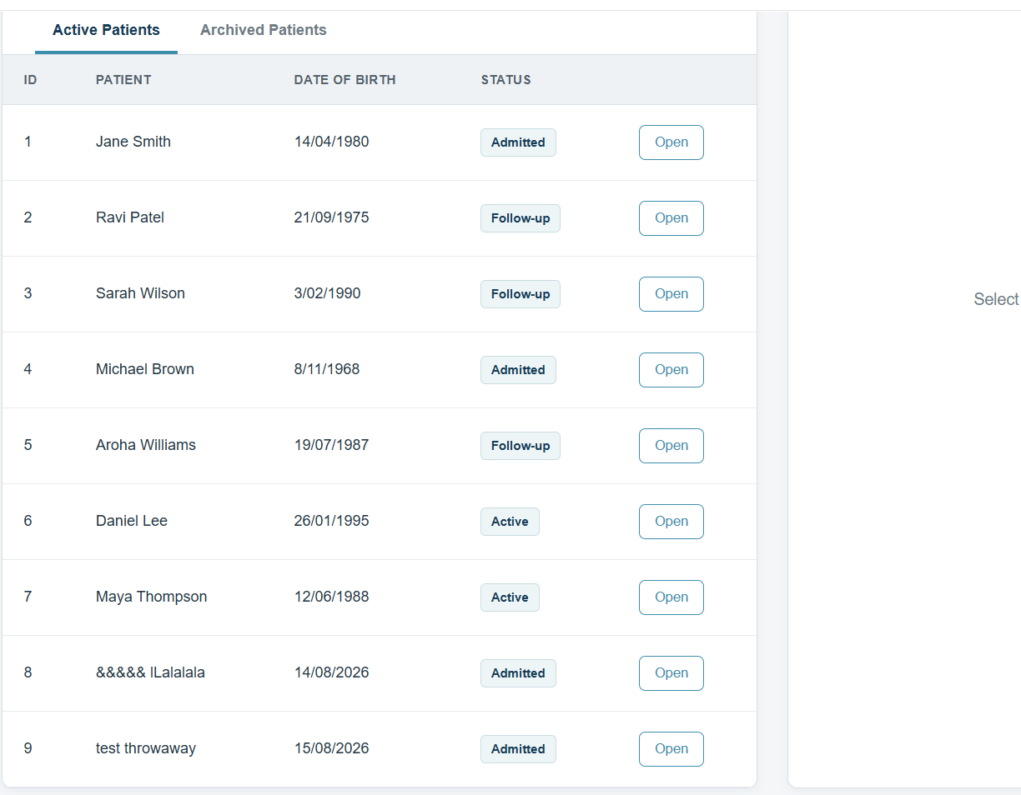
TC02 | The correct patient record was retuned for the id selected | Pass | Retrieve valid patient by ID | 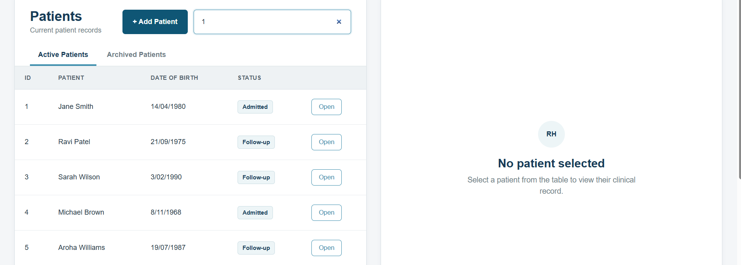 | 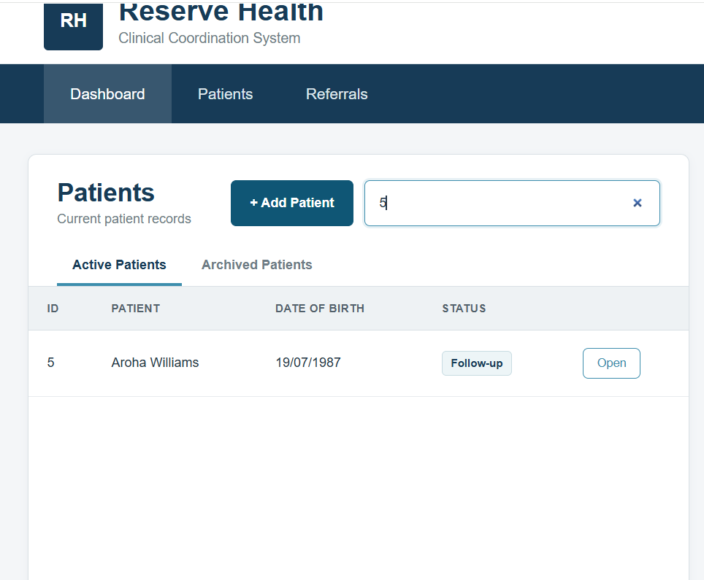
TC03 | As expected for a non-existent patient id a 404 to found was displayed as expected | Pass | Retrieve non-existent patient ID | 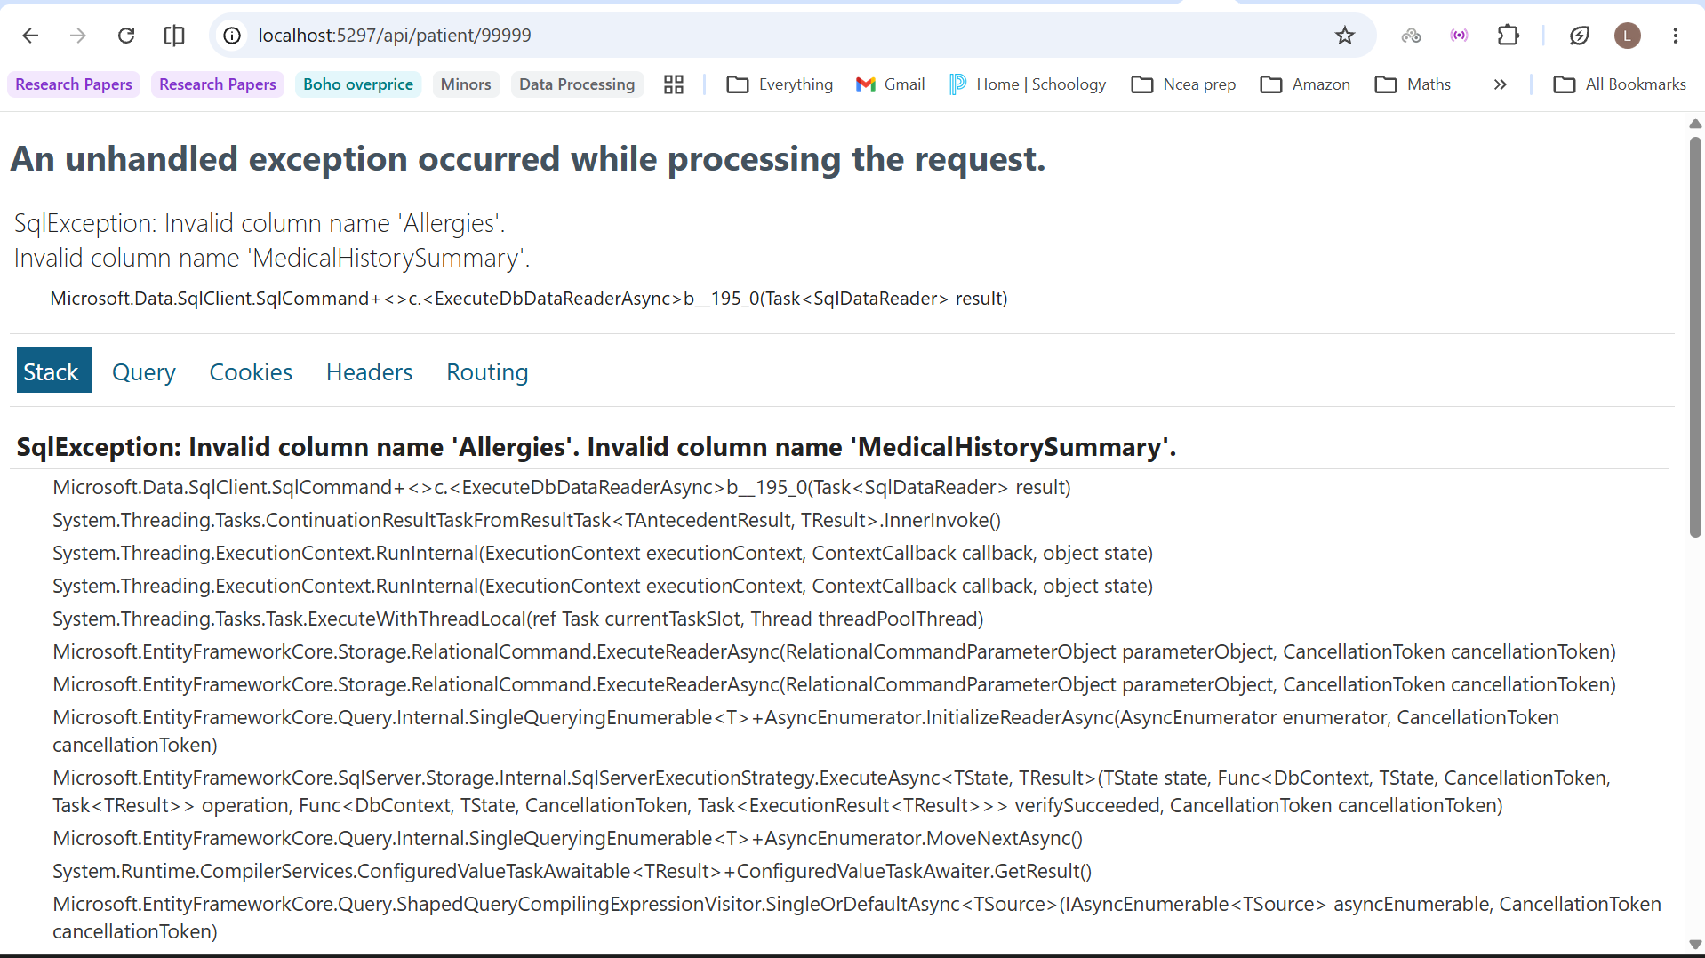 | 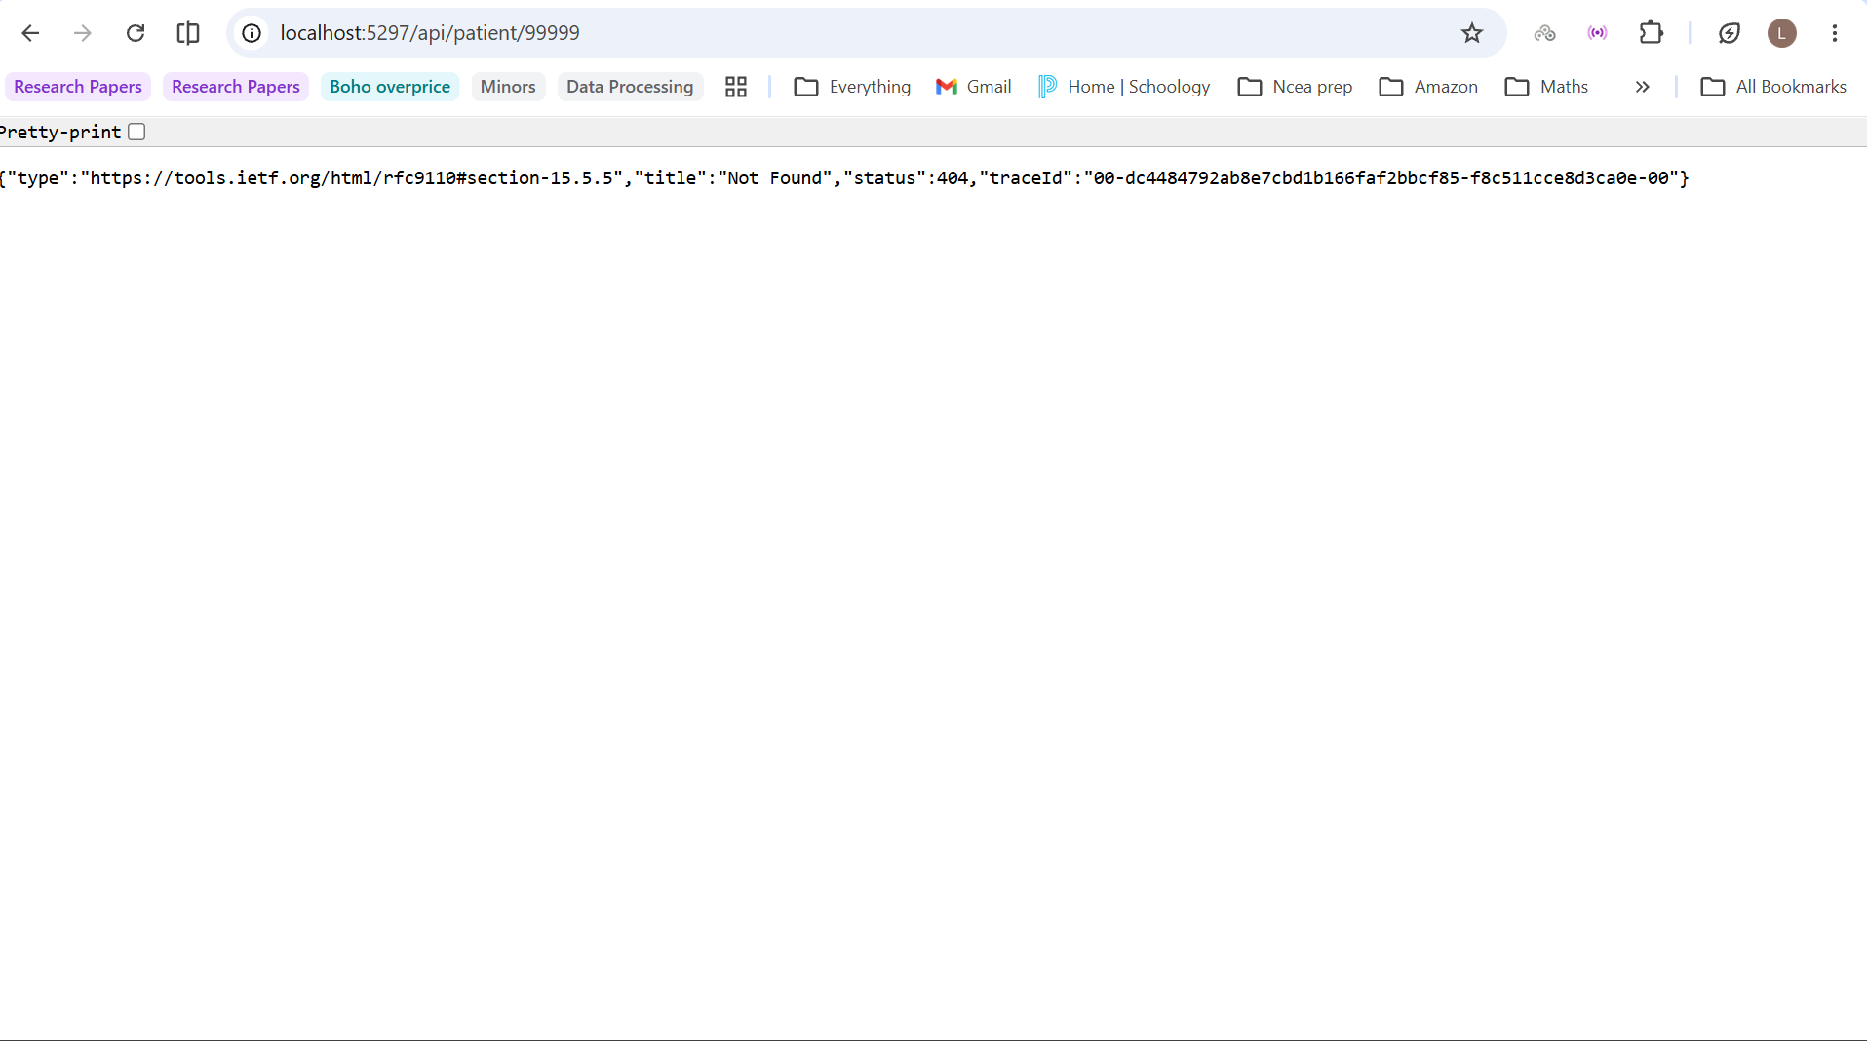
TC04 | The patient summary infomration was displayed correctly through the dashboard | Pass | Open patient summary/dashboard | Not Applicable | 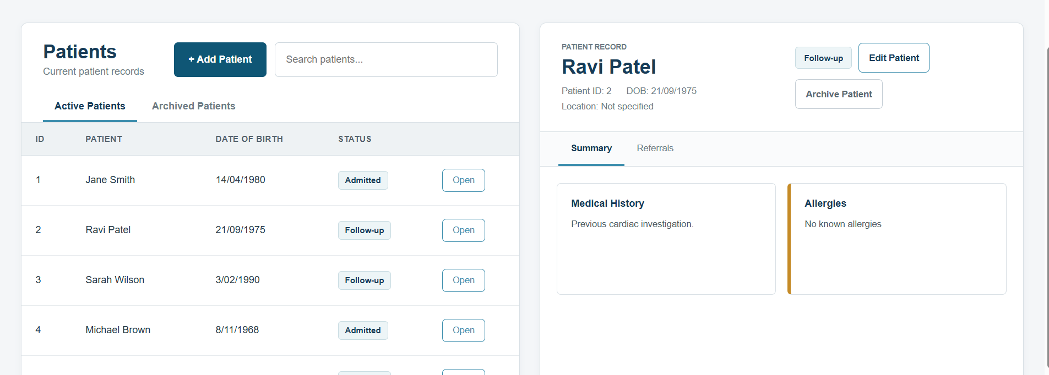

Table 4: Test Evidence

ID | Actual result | Status | Test | Result
TC05 | A valid referral successfully created and displayed in the referral list | Pass | Submit valid referral | 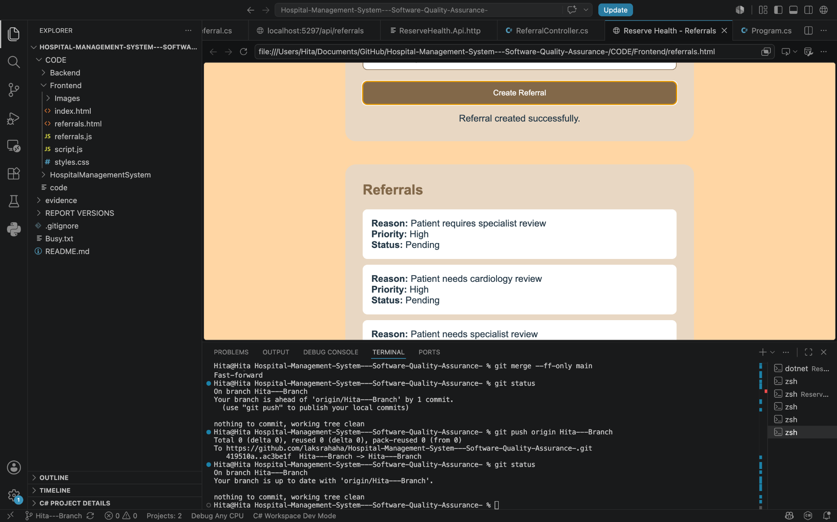
TC06 | A referral submitted without a reason was rejected and no incomplete referral was created. | Pass | Submit referral with no reason | 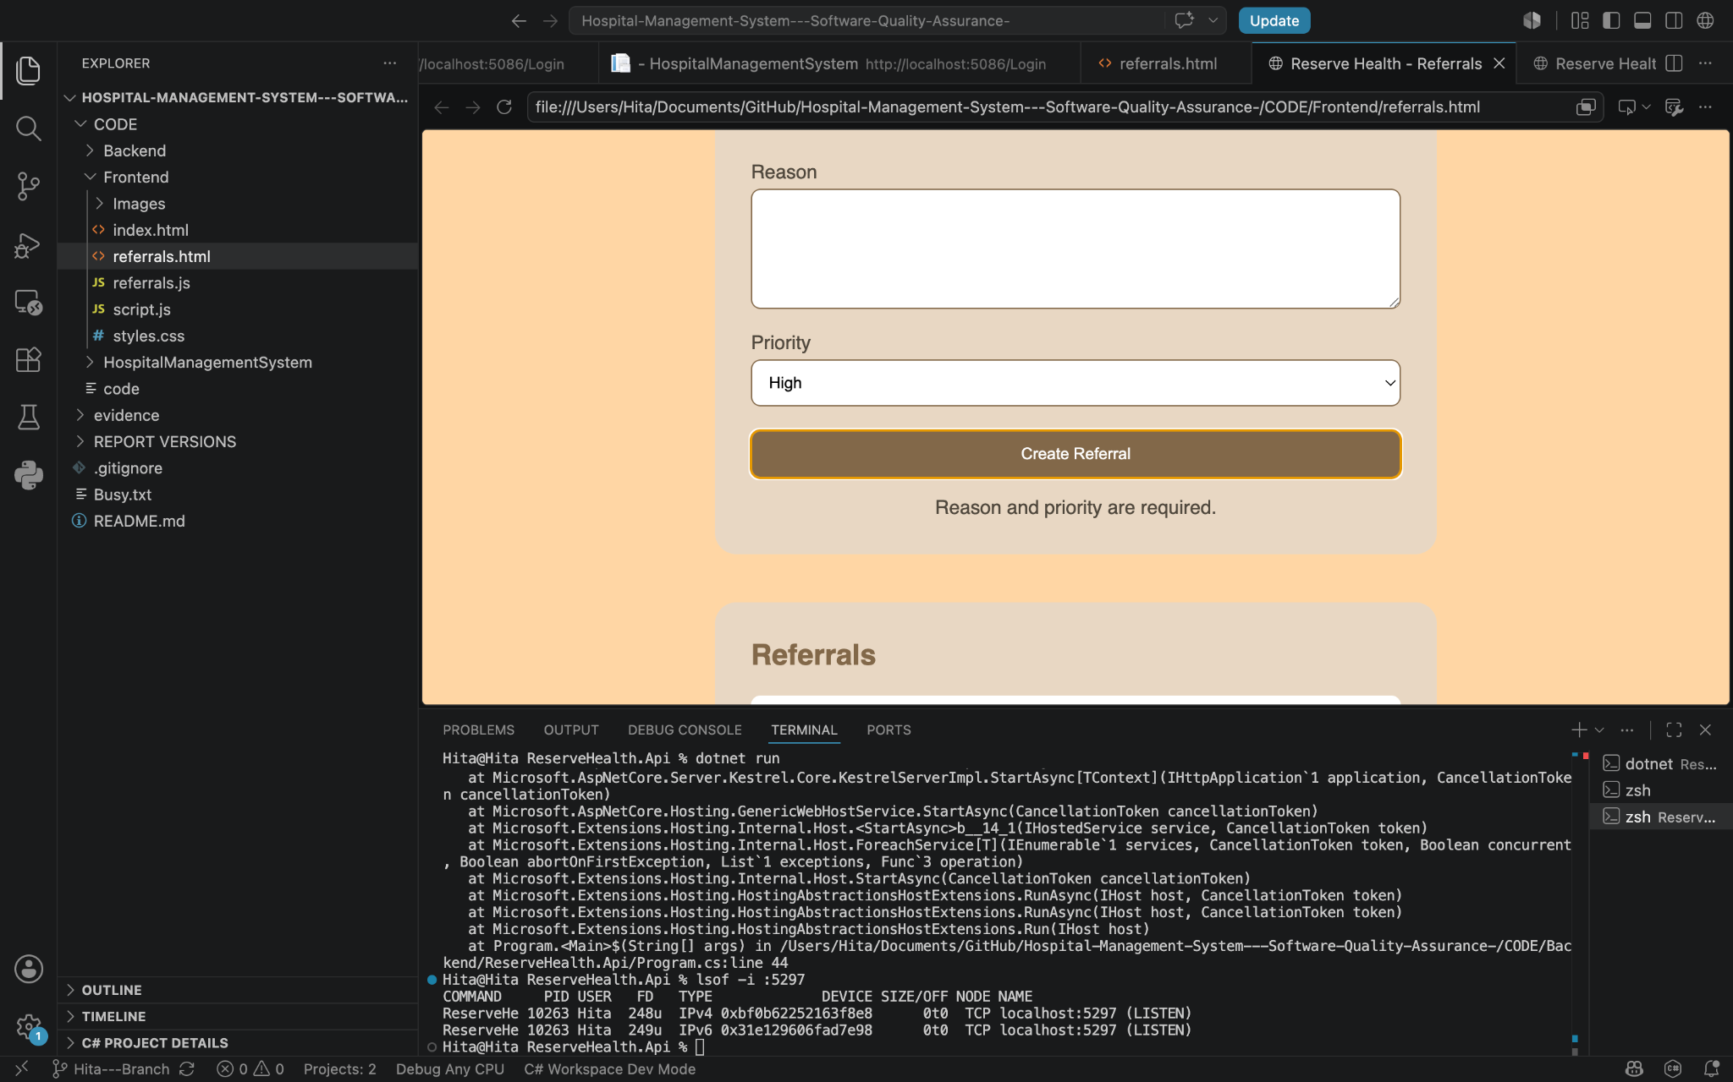
TC07 | A referral submitted without a priority was rejected and the user was asked to select a priority. | Pass | Submit referral with no priority | 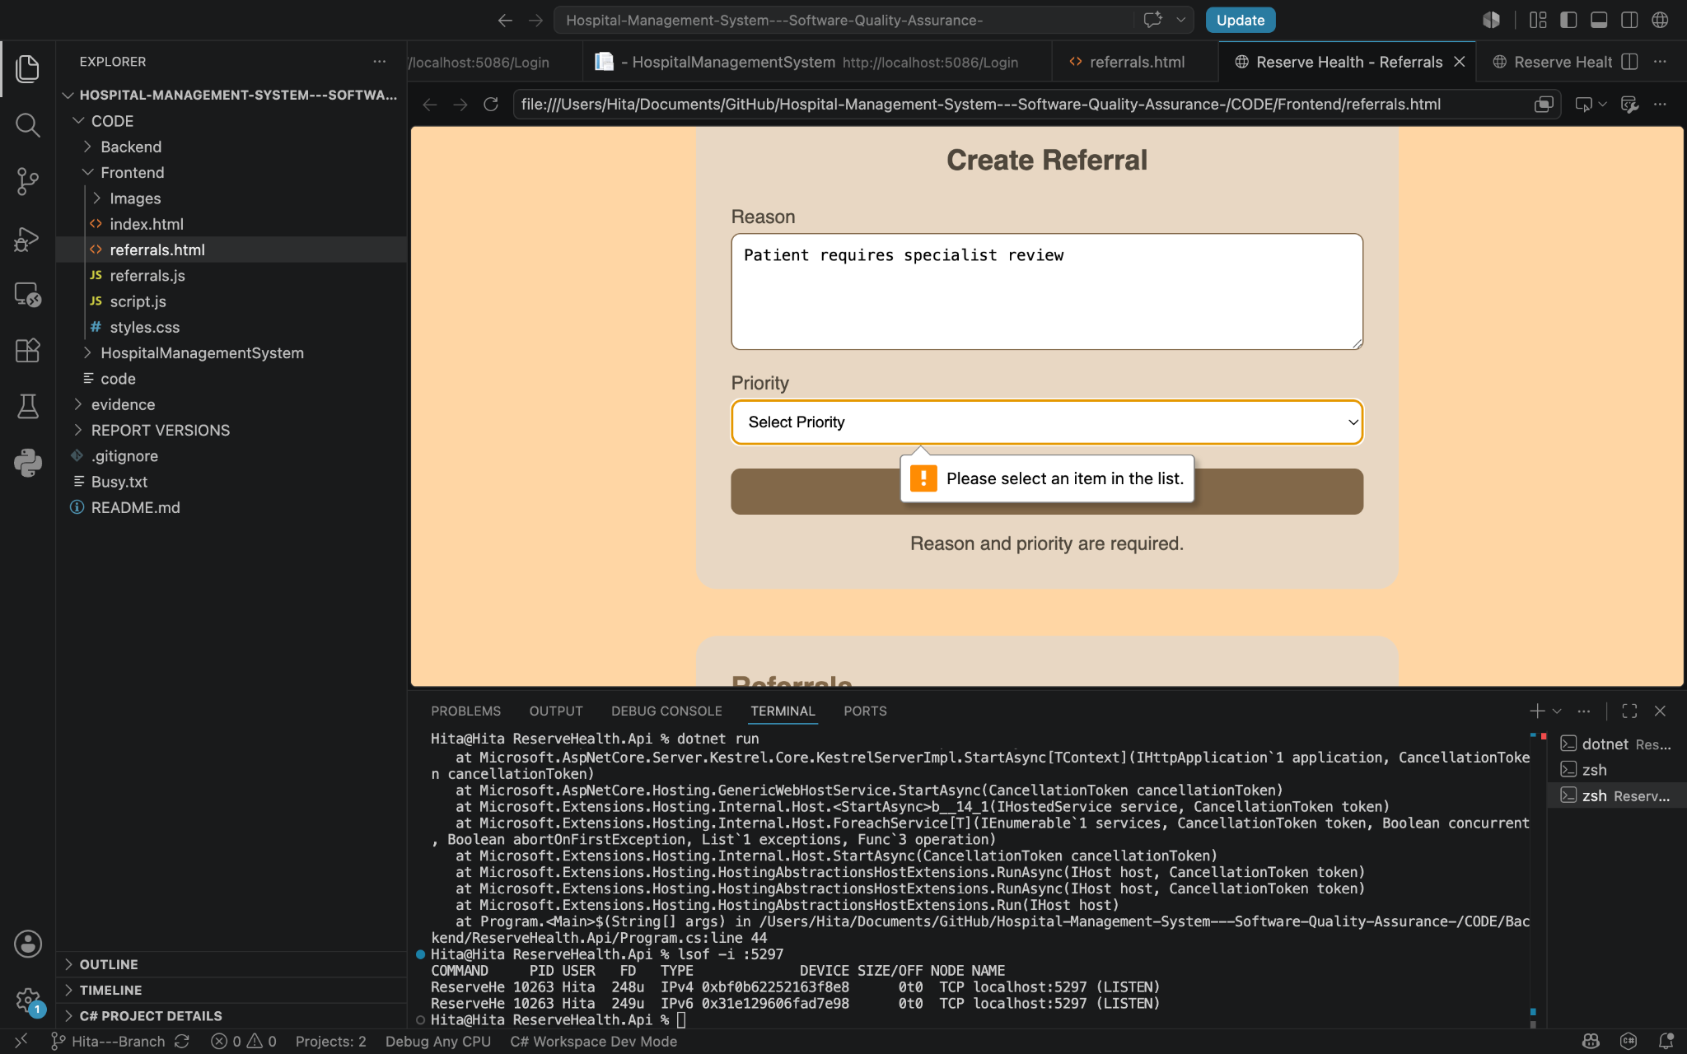
TC08 | The created referrals were retrieved and displayed with their initial Pending status. | Pass | Retrieve and display referral status | 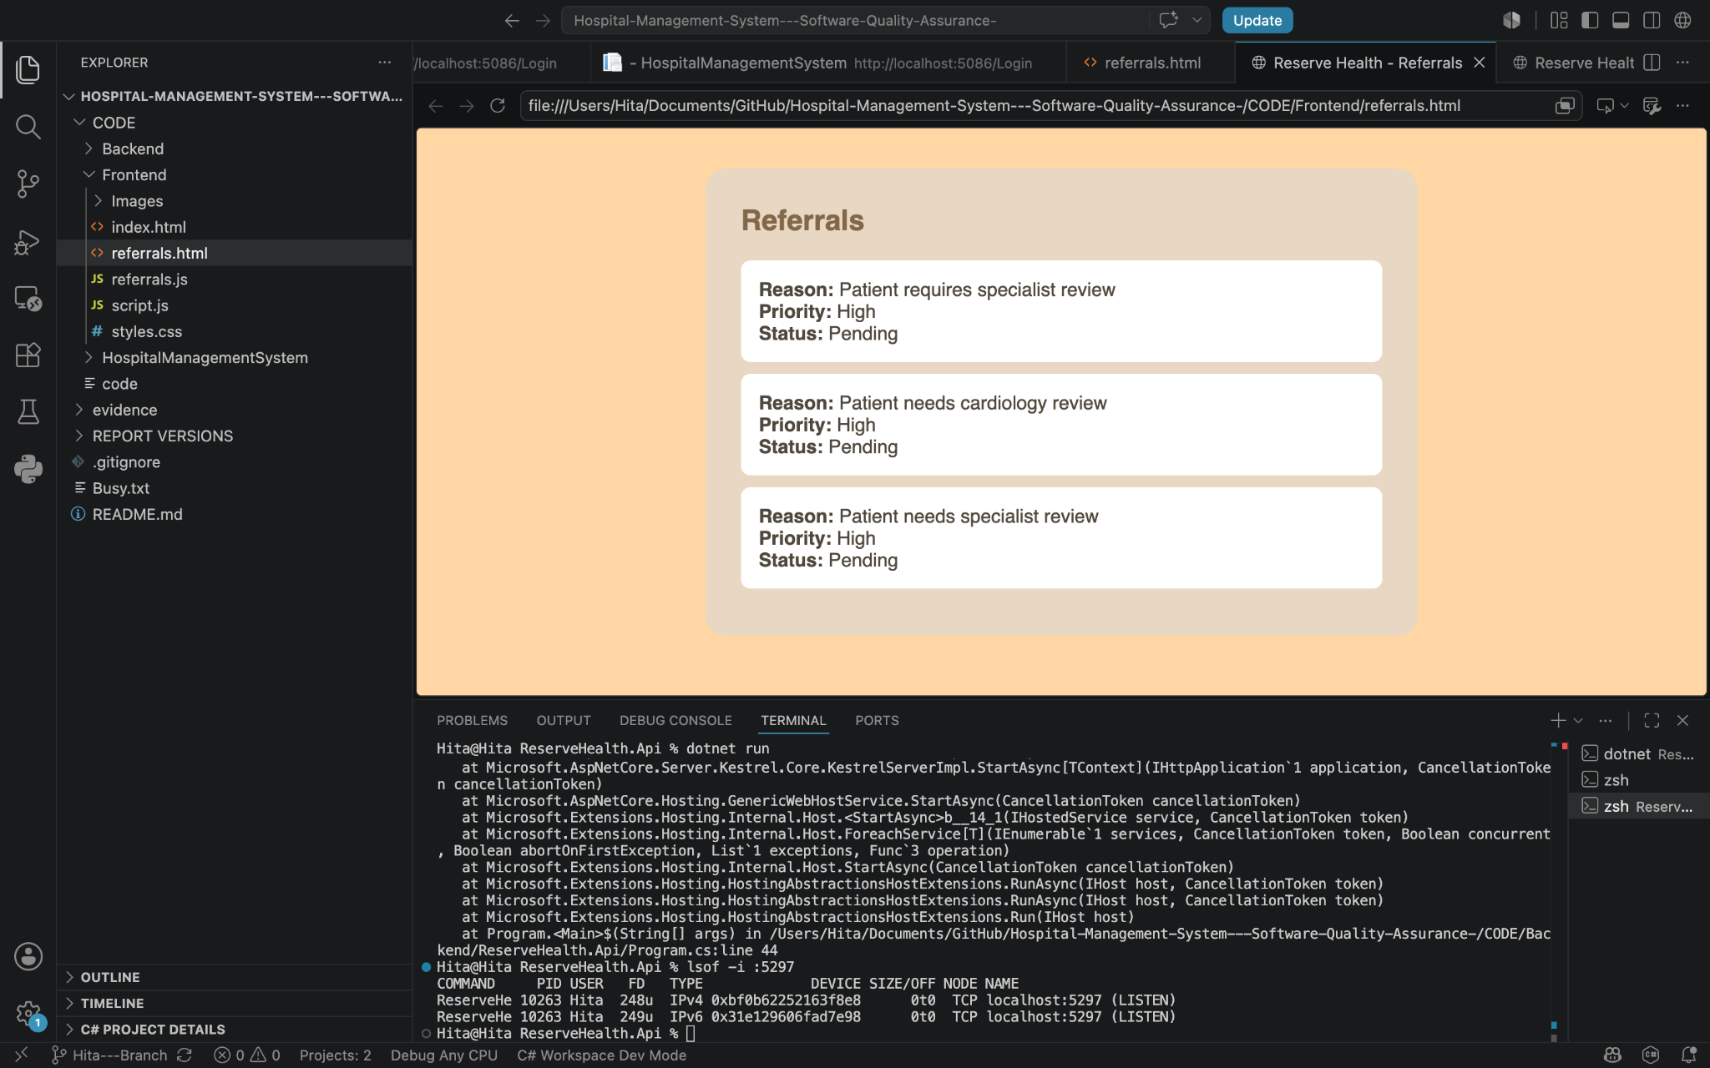

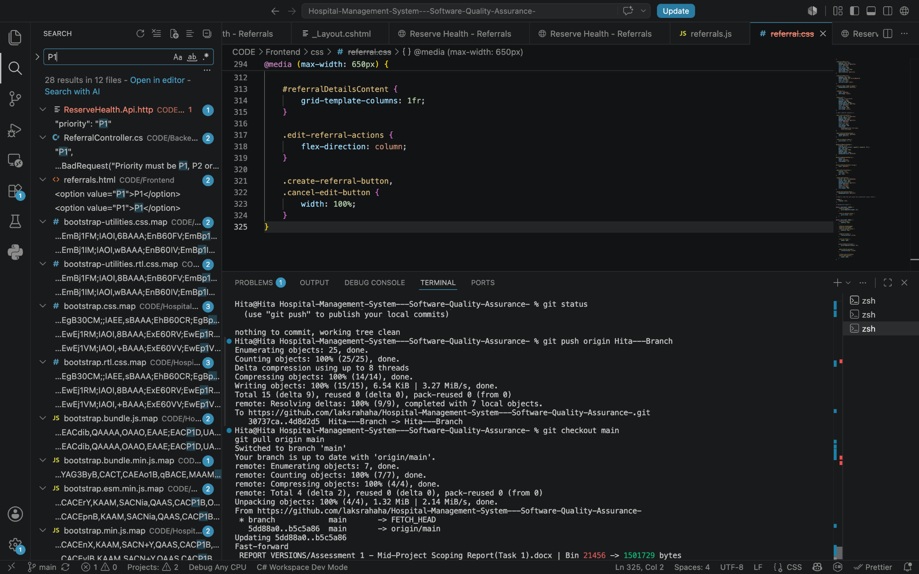(final merged priority confirmation)
Table 5: Test Evidence

6.3 Requirements traceability matrix
To maintain bidirectional traceability between requirements, acceptance criteria, and test cases the requirement traceability matrix was used. This ensured that the defined requirements had corresponding evidence and no major or crucial key requirement was left without appropriate test coverage. This also supported change management because any changes made to the requirement could be traced back to the related test cases so they could review or rerun.
Requirement | Purpose | Linked Test(s) | Owner | Status
FR01 | Display patient records | TC01 | Partner 1 | Pass
FR02 | Open individual patient record | TC02, TC03 | Partner 1 | Pass
FR03 | Display patient clinical summary | TC04 | Partner 1 | Pass
FR04 | Clinical dashboard overview | TC04 | Partner 1 | Pass
FR05 | Create referral | TC05 | Partner 2 | Pass
FR06 | Require referral reason | TC06 | Partner 2 | Pass
FR07 | Require referral priority | TC07 | Partner 2 | Pass
FR08 | Record/display referral status | TC08 | Partner 2 | Pass
NFR01 | Usability | TC04 | Partner 1 | Pass
NFR02 | Reliability/validation | TC06, TC07 | Partner 2 | Pass

Table 6: Requirements Traceability Matrix

Task 7: Progress, Risks and Next Steps

7.1 Current progress and limitations
The referral model and controller, referral creation, required-field validation, P1/P2/P3 priority handling, status handling and Edit Referral option have been completed at the current prototype level. The frontend communicates with the API so referrals can be created, retrieved, displayed, and updated. Valid and invalid referral submissions were also tested, and the completed changes were committed for integration.
A main challenge was keeping the referral page compatible with the new shared layout and separated styling while avoiding changes to IDs used by referrals.js. Another limitation was that I developed on a Mac, while the project's LocalDB setup required Windows, so the final database integration check was passed to my team member. Authentication, role-based access, and wider automated test coverage also remain incomplete, but the basic Login/Signup integration was completed

7.2 Risk and mitigation
Risk | Migration
Patient-referral integration | Strengthen the database relationship between patient and referral records  and allow referral information to be accessed through the patient record.
Invalid referral data | Maintain validation and add further negative and boundary tests.
Regression after merges | Rerun referral and patient integration tests after shared changes.
Security | Complete authentication and role-based access before production use.
Cross platform integration | Complete and record the final Windows/LocalDB test.
Limited coverage | Expand beyond TC05-TC08 during Part 2.

Table 7: Risk and Mitigation

7.3 Part 2 and future improvements
Part 2 will focus on strengthening the existing workflow. The next steps are to confirm the patient-to-referral relationship, improve validation and error handling, and add more negative, integration, and regression tests. Authentication and role-based access control will also be improved so users can only access information related to their role. The status workflow can be refined so Returned or Rejected referrals require a reason, and the RTM will be updated whenever a requirement or test changes. Additional hospital functions will only be included if they remain within the narrowed scope.

In the next stage of the project, the referral functionality can be improved further by creating a stronger connection between the patient and referral sections, so that referrals for a selected patient can be viewed directly from their patient record. The referral interface can also be improved by adding a clearer status editing bar or workflow which shows the progress of the referral from Pending through to Accepted, Returned, Rejected or Completed. Further improvements can also include clearer referral history and status changes, so users are able to follow what has happened to a referral over time.
Referral data is now stored in the database, however the relationship between patient and referral records can be developed further so that the system provides a more connected patient journey rather than treating the two sections separately.

Conclusion
The mid project prototype now demonstrates the main patient and referral workflows working together. Lecturer and stakeholder feedback helped us narrow the project into a clearer hospital workflow instead of trying to develop every feature at once. Initial requirements, testing, and traceability evidence have been established, while the referral side now supports creation, validation, P1/P2/P3 priority handling and status updates. Basic login page and signup page have also been implemented. Limitations remain around authentication, role-based security, and wider testing. In Part 2, the focus will be on strengthening, integrating, and testing the existing workflow so the system becomes more reliable and consistent with the agreed scope.

